Step by step guide for the Doctor

1. The Doctor logs on in the app

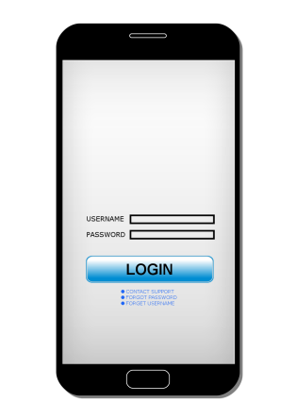

1. The doctor can access the patient’s history, comments, medication, pictures and see that the patient is getting the right care.

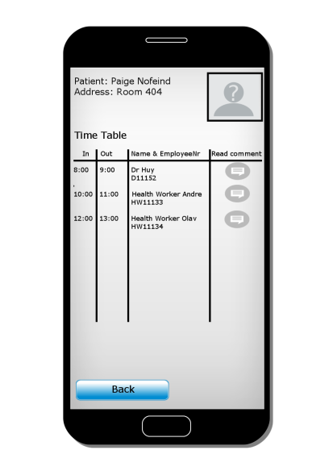

1. If needed the Doctor can send messages to the relevant parties

